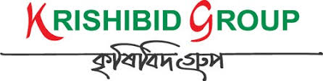

KG Asset Management

USER MANUAL

**Prepared by: IT Department, Krishibid Group**

Content

Introduction 2

Description of Asset Management System 2

The Importance of Asset Management System 2

Complete an Asset Inventory Error! Bookmark not defined.

1. Dashboard 3

**1.1 ERP Login Page** 3

**1.2 ERP Home Page** 4

2. Asset Management Setting 5

**2.1 Asset Location** 5

**2.2 Sub Location** 6

**2.3 Asset Category** 7

**2.4 Product** 8

3. Asset Management System 9

**3.1 Add New Asset** 9

**3.2 Asset List** 9

**3.3 Assign to User** 10

**3.4 Add New Land** 11

**3.5 Land List** 11

**3.6 Land Report** 12

# Introduction

The Krishibid Group has initiated development of Enterprise Resource Planning (ERP) with the essence of establishing an effective database, to address and strengthen existing information system through coordinating and networking of existing human resource data collection systems. Krishibid consulted a team of experts, department of IT of Krishibid Group to take the responsibility of developing, implementing and maintaining HRMS system in this organization. **As for any big system development the process is not an overnight thing.** **Work Management** **System** is evolving, though with a remarkable speed, the inputs of stakeholders are all time required.

This manual outlines the systematic procedures for accessing and using one of the most important parts of the KG ERP system. In case you do not get the assistance, you expected from the manual please consult your system administrator or any person authorized to work as the member of the helpdesk team at your organization.

# Description of Asset Management System

Asset management is the process of developing, operating, maintaining, and selling assets in a cost-effective manner. Most commonly used in finance, the term is used in reference to individuals or firms that manage assets on behalf of individuals or other entities.

Every company needs to keep track of its assets. That way, the relevant stakeholders will know just what assets are available and what can be used to provide optimal returns. The assets owned by any business fall into two main categories: fixed and current assets. Fixed or non-current assets refer to assets acquired for long-term use, while current assets are those that can be converted into cash within a short amount of time.

When it comes to asset management, there are two main things that individuals are interested in knowing. One, what role does the asset management process play? Two, how can a firm develop a good asset management plan?

# The Importance of Asset Management System

There are several reasons why businesses should be concerned about asset management, including:

* Enables a firm to keep tabs on all of its assets

The process makes it easy for organizations to keep track of their assets, whether liquid or fixed. Firm owners will know where the assets are located, how they are being put to use, and whether there are changes made to them. Consequently, the recovery of assets can be done more efficiently, hence, leading to higher returns.

* Helps guarantee the accuracy of amortization rates

Since assets are checked on a regular basis, the process of asset management ensures that the financial statements associated with them are kept updated.

* Helps identify and manage risks

Asset management encompasses the identification and management of risks that arise from the utilization and ownership of certain assets. This means that a firm will always be prepared to counter any risk that comes its way.

* Removes ghost assets in the company’s inventory

Instances exist where lost, damaged, or stolen assets are still recorded on the books. With a strategic asset management plan, the firm’s owners will be aware of the assets that have been lost and, thus, not keep recording them in the books.

Before anything else, an owner needs to take count of all the assets that he owns. If he is not aware of the exact number of assets in his inventory, then he won’t manage them effectively. When preparing an inventory of company assets, the following should be included:

* Total count of assets
* Where the assets are
* The value of each asset
* When the assets were acquired

# 1. Dashboard

## **1.1 ERP Login Page**

Open the browser and type the following address: http:// [http://192.168.0.7:90](http://192.168.0.7:90/) then a page similar to the one shown in the image below will be displayed whereby a user will be required to type in their correct **username** and **password**. This system works best with Google Chrome, Mozilla Firefox, Microsoft Edge or Opera browsers. From here on, the use of the word “browser” will refer to above mentioned web browsers only.

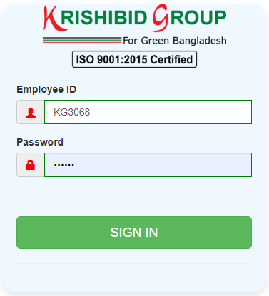

**Figure: 01 ERP Login**

**Logging on ERP System:**

* **Step-1:** Provide Valid **Username and Password. For Username Always Provide your Employee ID. (Example: EmployeeId: KGXXXX, Password: KGXXXX) with UPPERCASE.**
* **Step-2:** Click on **‘Sign In’** button for go to Home page of ERP.

## **1.2 ERP Home Page**

On successful login, a user is directed to the Home Page which consists of the main menu on the left side named dashboard. At the top most part of the system you will have on your left a home icon to denote the home page, a help button- which contains this help manual and the Employee Id of the user currently accessing the system.

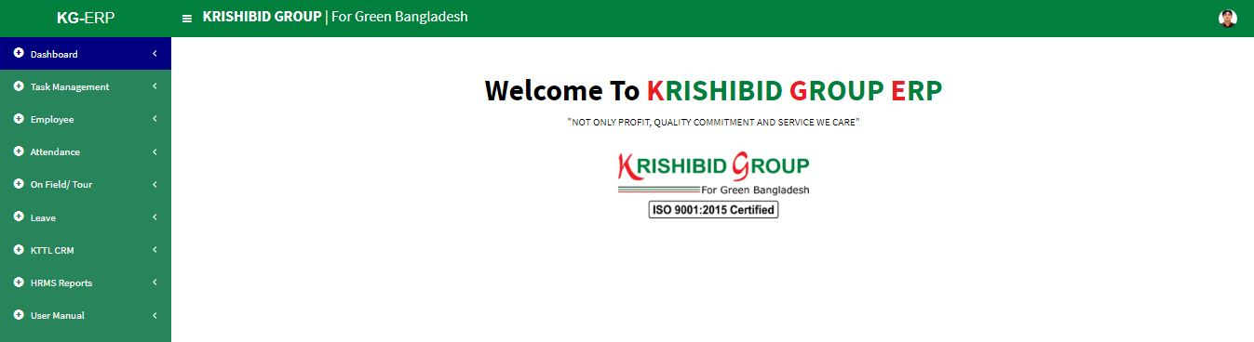The following figure (Fig-02) shows menu bar and home page.

**Figure: 02 ERP Home Page**

* **Step-01:** Click on the Dashboard section under main navigation panel of KG ERP.

# 2. Asset Management Setting

## **2.1 Asset Location**

**Figure: 03 Location**

* Click on the **Location** section under **Asset Management (Setting)** option. The following figure (Fig-03) shows the location information based on all necessary status for any asset.
* **Step-01:** Click on “**+Add**” Button for adding new Asset Location. Enter **‘Location’ then** click on **Create** button for save any new Asset Location. Serial number will be auto generated.
* 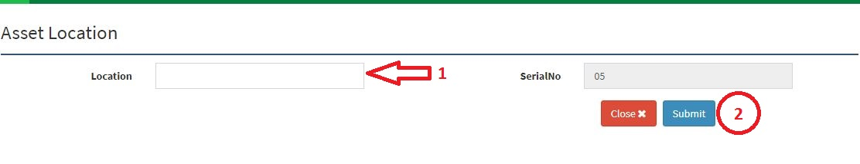**Step-02:** Click on Edit Button or Delete Button. User can **Update** or **Delete** any state which one is not dependent any Asset Location.

**Figure: 04 Asset Location Entry Page**

## **2.2 Sub Location**

**Figure: 05 Sub Location**

* Click on the **Sub Location** section under **Asset Management (Setting)** Menu option.
* **Step-01:** Click on “**+Add**” button and Enter **“Location” and “Sub Location”** Click on Save button to add new Asset Sub Location for product. (Fig: 06). Serial number will be auto generated.
* **Step-02:** Click on Edit or Delete Button. Authorized person can **Update** or **Delete** any sub location which one is not dependent any Assign product.

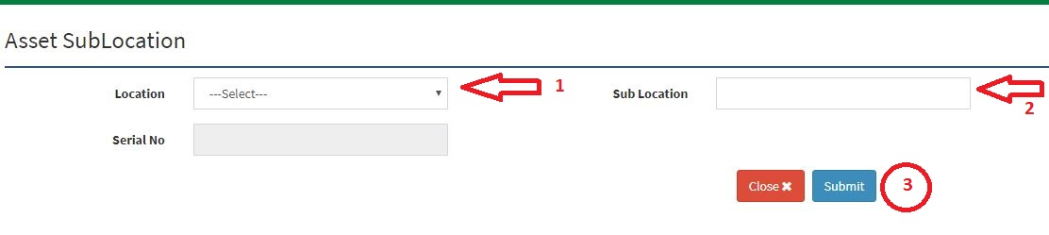

**Figure: 06 Asset Sub Location Entry Page**

## **2.3 Asset Category**

**Figure: 07 Asset Category Page**

* Click on the **Asset Category** section under **Asset Management (Setting)** Menu option.
* **Step-01:** Click on “**+Add**” button and Enter **“Category”** Click on Save button to add new Asset Sub Location for product. (Fig: 08). Serial number will be auto generated.
* **Step-02:** Click on Edit or Delete Button. Authorized person can **Update** or **Delete** any Category which one is not dependent any Assign product.

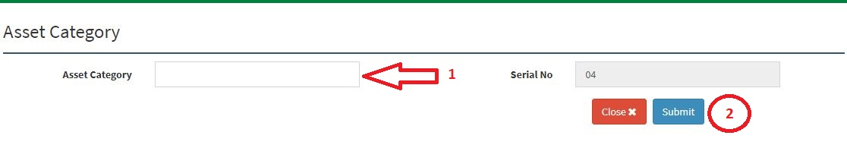

**Figure: 08 Asset Category Entry Page**

## **2.4 Product**

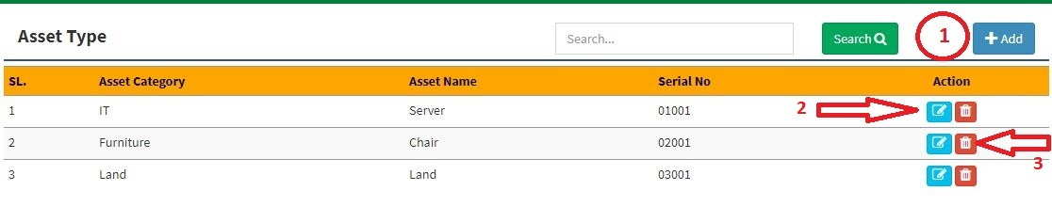

**Figure: 09 Asset Product Type List Page**

* Click on the **Asset Product Type** section under **Asset Management (Setting)** Menu option.
* **Step-01:** Click on **“+Add**” button and Enter **“Asset Category” and “Asset Name”** Click on Save button to add new Asset Sub Location for product. (Fig: 10). Serial number will be auto generated.
* **Step-02:** Click on Edit or Delete Button. Authorized person can **Update** or **Delete** any Category which one is not dependent any Assign product.

# 3. Asset Management System

## **3.1 Add New Asset**

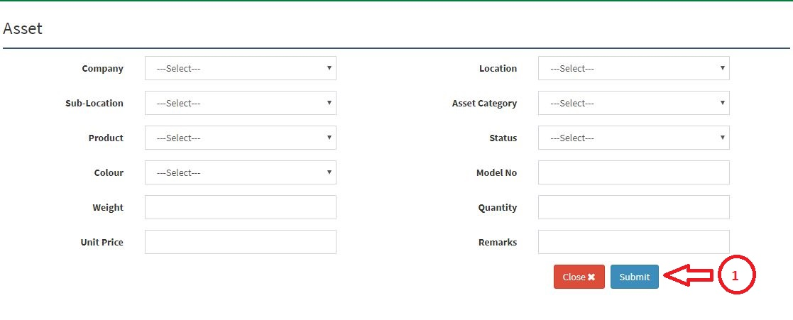

**Figure: 11 Add New Asset Entry Page**

* Click on the **Asset Product Type** section under **Asset Management System** Menu option.
* **Step-01:** Enter **‘Company’, ‘Location’, ‘Sub Location’, ‘Asset Category’, ‘Product’, ‘Status’, ‘Colour’, ‘Model No’, ‘Weight’, ‘Quantity’, ‘Unit Price’ and ‘Remarks’** thenClick on **Submit** button to add new Asset in the List view.

## **3.2 Asset List**

**Figure: 12 Asset List Page**

* Click on the **Asset List** section under **Asset Management System** Menu option.
* **Step-01:** Click on **“+Add**” button and Enter **‘Company’, ‘Location’, ‘Sub Location’, ‘Asset Category’, ‘Product’, ‘Status’, ‘Colour’, ‘Model No’, ‘Weight’, ‘Quantity’, ‘Unit Price’ and ‘Remarks’** thenClick on **Submit** button to add new Asset in the List view. (Fig: 11)
* **Step-02:** Click on Edit or Delete Button. Authorized person can **Update** or **Delete** any asset which one is not dependent any Asset product.

## **3.3 Assign to User**

**Figure: 13 Asset Assign List Page**

* Click on the **Asset List** section under **Asset Management System** Menu option.
* **Step-01:** Click on **“+Add**” button and Enter **‘Company’, ‘Location’, ‘Sub Location’, ‘Category’, ‘Asset Type’, ‘AssetId’, ‘Assign To’ and ‘Remarks’** thenClick on **Submit** button to add new Asset in the List view. (Fig: 14)
* **Step-02:** Click on Edit or Delete Button. Authorized person can **Update** or **Delete** any asset which one is not dependent any Asset product.

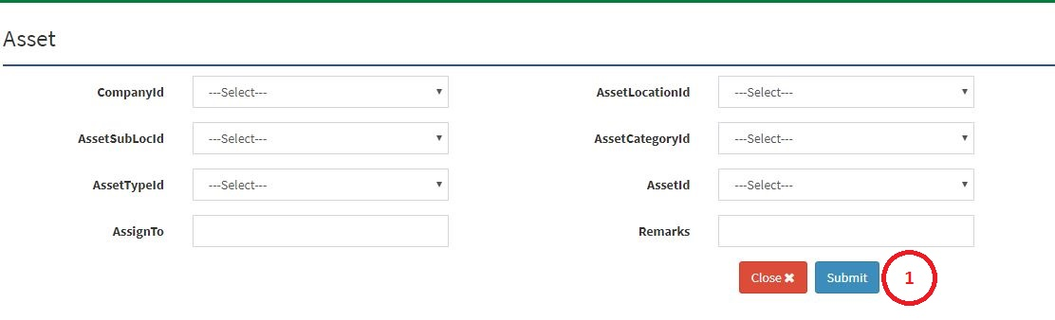

**Figure: 14 Asset Assign Entry Page**

## **3.4 Add New Land**

**Figure: 15 Add New Land Entry Page**

* Click on the **Asset List** section under **Asset Management System** Menu option.
* **Step-01:** Enter **‘Company’, ’District’, ‘Upazila’, ‘Unions’, ‘Mouja’, ‘Name of the Receiver’, ‘Name of the Donor’, ‘Deed no’, ‘Deed of Date’, ‘Amount of Land Purchased’, ‘Bia Deed No and Date’, ‘CS’, ‘CS Dag’, ‘SA’, ‘SA Dag’, ‘RS’, ‘RS Dag’, ‘BS’, ‘BS Dag’, ‘Total Land of SA Dag’, ‘Purchase Land of SA Dag’, ‘Total Land of RS Dag’, ‘Total Land of BS Dag’, ‘Jot No’, ‘Dag No’, ‘Khatian No’, ‘Amount of Registered Land’, ‘Remaining Land’ and ‘Remarks’** thenClick on **Submit** button to add new Land information in the List view. (Fig: 15)
* **Step-02:** Click on Edit or Delete Button. Authorized person can **Update** or **Delete** any asset which one is not dependent any Asset product.

## **3.5 Land List**

**Figure: 16 Add Land List Page**

* Click on the **Asset List** section under **Asset Management System** Menu option.
* **Step-01:** Click on **“+Add**” button and Enter **‘Company’, ’District’, ‘Upazila’, ‘Unions’, ‘Mouja’, ‘Name of the Receiver’, ‘Name of the Donor’, ‘Deed no’, ‘Deed of Date’, ‘Amount of Land Purchased’, ‘Bia Deed No and Date’, ‘CS’, ‘CS Dag’, ‘SA’, ‘SA Dag’, ‘RS’, ‘RS Dag’, ‘BS’, ‘BS Dag’, ‘Total Land of SA Dag’, ‘Purchase Land of SA Dag’, ‘Total Land of RS Dag’, ‘Total Land of BS Dag’, ‘Jot No’, ‘Dag No’, ‘Khatian No’, ‘Amount of Registered Land’, ‘Remaining Land’ and ‘Remarks’** thenClick on **Submit** button to add new Land information in the List view. (Fig: 15)
* **Step-02:** Click on Edit or Delete Button. Authorized person can **Update** or **Detail** any asset which one is not dependent any Asset product.

## **3.6 Land Report**

**Figure: 17 Land Report**

* Click on the **Land Report** section under **Asset Management System** Menu option.
* **Step-01:** Select **‘Company’ then** Click on **View Report** button to view company wise Report in the Grid view. (Fig: 17).
* **Step-02:** Click on Export Button to select what type of format you may choose. Only Authorized person can export report by using this menu.